**Electric Circuits (EE 100) Lab Manual Handout # 7**

|  |  |
| --- | --- |
| **Name** | Muhamad Asad |
| **Reg. No** | 2019-EE-383 |
| **Marks / Grade** |  |

# EXPERIMENT NO. 7

**THE NODE-VOLTAGE AND MESH-CURRENT METHOD**

## Objective:

To study the validity of the Node-voltage and the Mesh-current method.

## Apparatus:

1. Resistors
2. Digital MM
3. Breadboard
4. DC power supply
5. Connecting wires

## Pre-requisite

Before coming to the lab, students must study and practice the node-voltage and mesh-current methods. Also review the theoretical concepts relating Kirchhoff’s voltage and current laws.

**Safety Precautions**

* Look at each exercise carefully before connecting the circuits.
* Make sure all power is off before connecting or disconnecting components.
* Ask your Instructor to check the circuit before turning on the power.
* When measuring voltage or current, make sure the DMM is correctly set for what you need to measure.

**Electric Circuits (EE 100) Lab Manual Handout # 7**

## Procedure:

**PART 1: NODE-VOLTAGE METHOD**

The node-voltage method uses KCL equations that are written at all non- reference nodes. Recall that KCL states that the sum of all the currents at a node is zero. The node- voltage method is comprised of the following steps:

1. Identify all the nodes in a circuit.
2. Choose one of the nodes as the reference node (usually a low potential node).
3. Assign variable names to each of the essential (non-reference) nodes. Mark voltages as per the variable names assigned to each node e.g. *va*, *vb*, *vc*, etc.
4. Determine the direction of currents i.e. mark voltage polarities across each circuit element.
5. Write a KCL equation in terms of node-voltages at each of the non-reference nodes. The result will be *(n-1)* equations where *n* is the number of essential nodes plus a reference node.
6. Solve the equations and verify values through measurements.

## Circuit Diagram:

10V



a

R4

b

c

1

R1

R3

R2

5V

**Figure 7.1**

## Calculation & Observation:

|  |  |  |  |  |
| --- | --- | --- | --- | --- |
| Resistance values | Calculation results | | Measurement results | |
| Voltage | Current | Voltage | Current |
| R1=3 | 14.33 | 4.76 |  |  |
| R2=5 | -4.333 | -0.866 |  |  |
| R3=7 | -9.33 | 1.33 |  |  |
| R4=9 | 5 | 0.555 |  |  |

### Note: In the calculations, first write the equation for all the currents in terms of node voltages and resistances. For example, in fig. 7.1, the current flowing through R2 is Vb/R2.

**PART 2: MESH-CURRENT METHOD**

The mesh-current method, like the node-voltage method, provides a systematic means to specify the equations needed to solve a circuit. The method uses the meshes in a circuit. A mesh is a loop in the circuit that does not contain any other loops within it. The mesh-current method uses KVL equations that are written for each mesh in the circuit. Recall that KVL states that the sum of all the voltages drops and rises around a closed path (or loop) is zero. The mesh-current method can be broken into the following steps:

1. Identify all the meshes in a circuit. To do this draw a curved arrow to identify the direction (clockwise, conventionally) of the current flowing in the mesh.
2. Assign variable names to each of the meshes. Mark currents as per the variable names assigned to each mesh e.g. *Ia*, *Ib*, *Ic*, etc.
3. Write a KVL equation in terms of mesh-currents for each of the meshes in the circuit. The result will be *n* equations where *n* is the number of meshes.
4. Transform all the equations into standard form. The resultant equations can be solved using matrix method or any other method of your choice.
5. Solve the equations for the currents. Find voltage across each component using Ohms law. Finally verify the values through measurements and fill in the table given below.

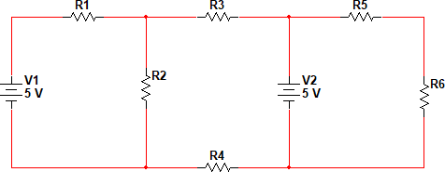

**Figure 7.2:** Example circuit to test the validity of the mesh-current method

## Calculation & Observations

|  |  |  |  |  |
| --- | --- | --- | --- | --- |
| Resistance values | Calculation results | | Measurement results | |
| Voltage | Current | Voltage | Current |
| R1 =3 | 2.0625 | 0.68 |  |  |
| R2 =5 | 0.5 | -0.1 |  |  |
| R3 =7 | 1.43 | 0.217 |  |  |
| R4 =9 | 1.677 | 0.64 |  |  |
| R5 =11 | 3.1 | 1.1 |  |  |
| R6 =13 | 0.8 | 0.1 |  |  |

### Note: In the calculations, also write the equation for all the currents in terms of resistances.

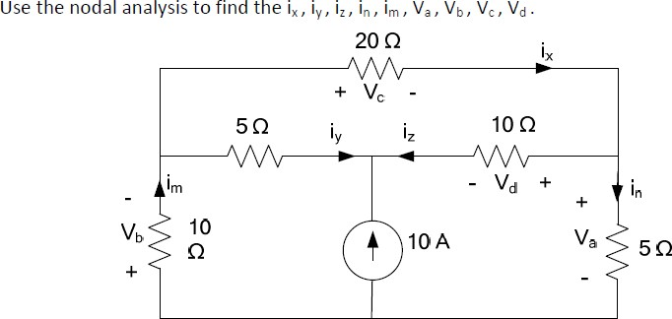**Task:**

